MEMORANDUM OF UNDERSTANDING

BETWEEN

SOUTHERN AFRICAN WILDLIFE COLLEGE

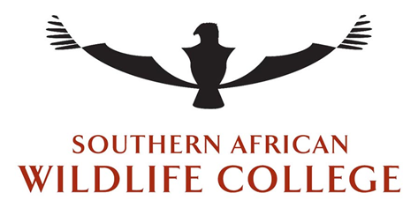

AND

School of Biology and Environmental Sciences
Faculty of Agriculture and Natural Sciences
University of Mpumalanga

MoU Title:
Agreement of collaboration between the Southern African Wildlife College and the School of Geography and the Environment, Oxford University

ORGANISATIONAL CONTEXT:
- The Southern African Wildlife College (SAWC)

The Southern African Wildlife College was established in 1996 by the World Wide Fund for Nature, South Africa (WWF-SA) in close cooperation with interested and affected parties in southern Africa, including national and provincial government departments, other conservation agencies and the Southern African Development Community (SADC). The SAWC is an independent SADC training institution and does not receive a government subsidy.

Incorporated in the Republic of South Africa under Section 21 of the Companies Act, 1973 (Act 61 of 1973), SAWC is a legal association with the registered name of the Southern African Wildlife College - Registration Number 1996/005726/08. The College’s NPC Registration Number is 046-675-NPC and PBO Registration Number 930016093.

Registered as a non-profit public benefit organisation the SAWC is proudly supported by both WWF-SA and the Peace Parks Foundation together with SACET, an independent Trust Fund set up by WWF-SA in 1999 to provide a reliable income stream for the Wildlife College in perpetuity.

The SAWC is currently provisionally registered with the Department of Education and training as a private Higher Education Institution under the Higher Education Act, 1997. The registration number with the Department of Education is Reg. No. 2008/FE08/003 and the College has this provisional registration status until 31 December 2018.

Recognised by the South African Department of Environmental Affairs, as a credible and long standing non-government conservation organisation (NGO), the SAWC is an approved project for Socio Economic Development under the Broad-based Economic Empowerment Act 53 of 2003 and the Codes of Good Practice on Broad-based Economic Empowerment. SAWC is registered as a VAT vendor with the South African Revenue Services (SARS) - VAT Registration No: 4370159610 and Tax Reference No: 9508059640.

The principal business and corporate direction of the SAWC is encapsulated in its vision to empower future leaders in the fields of tourism and conservation. The major stakeholders include conservation agencies, tourism and hospitality sectors, local communities and private business. Since inception, more than 15,000 students from 26 countries in Africa, but mostly from countries in the SADC region, have received training in natural resource management through the SAWC. Close on 900 students have completed qualification courses and 6397 have been through targeted skills development courses. A further 7946 have completed short course programmes at the College.

Approximately 80% of the learners who have received training at the SAWC since 1997 are still in wildlife management and most of the graduates have been promoted to more senior management positions. To date over R100-million has been spent on capacity building throughout Africa through the efforts of the Southern African Wildlife College and with the assistance of PPF and WWF-SA. By expanding its reach and becoming involved in training ventures and projects off-site the College has also capacity-built over 2000 previously disadvantaged South Africans.

Conservation: The Southern African Wildlife College aims through cutting edge, hands-on training programmes, to produce highly competent and motivated conservation practitioners. They are then able to apply these conservation techniques in their areas in order to sustain its associated fauna and flora. In striving to develop the potential of its learners, the College delivers on its mandate to equip learners to deal with the key challenges facing conservation. The SAWC delivers training to conservation professionals, communities and others in a ‘learning-by-doing’ approach and at the same time monitors and analyses the impacts this training has on the conservation industry and community members’ livelihoods. This approach has led to research and innovation be part of our core structure. It also means we run needs based short courses and specially developed modules in our higher and further education programs. Our learning by doing approach, through the SAWC Applied Learning Unit, offers great opportunities for applied research into these innovations and practices. This philosophy as well as the physical positioning of the SAWC campus, in a wildlife area with neighbouring communities, makes the College ideal for both training & applied research.

Partnership: Nurturing partnerships with people, organizations and governments to benefit people & conservation in Africa.

Openness: Adopting an “Open Access” data sharing paradigm that maximizes the benefit derived from data collectively gathered, thus advancing interdisciplinary research and informing conservation needs.

Innovation: Continuing to incorporate the latest ideas and technologies into conservation with the aim of developing best practice.

Education: Providing training and research opportunities to the next generation of people associated with conservation and the wildlife economy.

- School of Biology and Environmental Sciences, Faculty of Agriculture and Natural Sciences, University of Mpumalanga

…………..

DECLARATION OF COMMON OBJECTIVE
- It is the aim of both the Southern African Wildlife College and the University of Mpumalanga, to apply their skills and resources in such a way so as to improve the many aspects of conservation training. These will include economic, social and ecological factors and how they are integrated. The aim is also to apply the teaching in such a way that will use new technologies and pathways for uptake. The Southern African Wildlife College and the University of Mpumalanga also recognise that they need the skills and resources of the other Party in order to improve their impact on the roll-out of their teaching, learning and research services. Details of how the collaboration at the project level will take place will form annexe A to this document. Modifications can be made in writing and with written consent from the other party.

- Key strategies:
  - To collaborate on projects the results of which will provide benefits to both institutes. From the side of University of Mpumalanga it will allow students to be immersed in real conservation issues and be part of a team solving the issue. From SAWC’s perspective it will increase the institutes’ capacity to carry out the required research in order to improve conservation and its associated industry.
  - Either individually or jointly develop funding proposals, or seek funding, for both on going or new projects that have potential for collaboration.
  - Projects seen as suitable will be communicated between the institutes and agreed upon in writing.
  - To benchmark each institutions programmes for best practice purposes. This will include examining opportunities for qualification Articulation, Recognition of Prior Learning and Credit and Accumulation and Transfer schemes for the institutions qualifications as highlighted in Annexure.
  - This enabling process in objectives d can then open up their careers to post graduatestudies.
  - For the SAWC to become an Applied Learning site for the University of Mpumalanga and a host site wherein students can complete there WIL.
  - Hold quarterly planning and management engagements.

Definitions
The headings of the clauses in this Memorandum of Understanding (“MoU”) are:
for the purpose of convenience and reference only, and shall not be used in the interpretation thereof and shall not modify or amplify the terms of this MoU or any clause hereof in this MoU unless a contrary intention clearly appears

words importing –
- any one gender include the other gender;

- the singular include the plural and vice versa; and

- natural persons include created entities (corporate and unincorporated) and vice versa.

The following terms shall have the meanings assigned to them hereunder and cognate expressions shall have a corresponding meaning, namely:

- “Southern African Wildlife College” shall mean Southern African Wildlife College, in accordance with the laws of South Africa;

- “____” shall mean the ______________

- “The Parties” in this MoU shall refer to Southern African Wildlife College and the School of Biology and Environmental Sciences, Faculty of Agriculture and Natural Sciences, University of Mpumalanga.

Scope of agreement:
The need for a MoU between the SAWC and the School of Biology and Environmental Sciences, Faculty of Agriculture and Natural Sciences, University of Mpumalanga reflects the dynamic and changing nature of the global conservation landscape in which peer organisations are collaborating in new, diverse and innovative ways through peer-aligned networks and common-interest partnerships. To this end both organisations agree to pursue the joint objectives as described above.

CONFIDENTIALITY, TRADEMARKS and INTELLECTUAL PROPERTY RIGHTS
- Any disclosure by either Party of information provided by the other Party under the terms and conditions of this collaborative MoU will be done only with the prior written consent of the Party providing the information. This undertaking does not apply to information that is publicly available at the date of disclosure or which thereafter becomes publicly available from sources other than the Parties.

- No announcements of any nature whatsoever relating to this MoU will be made by or on behalf of one Party to this MoU without the prior written consent of the other Party to this MoU.

- The Southern African Wildlife College’s trademarks are governed by Southern African Wildlife College and Southern African Wildlife College policies and trademark legislation, and may not be used in any format, anywhere, without the Southern African Wildlife College’s express written permission. Where express written permission is given, the Southern African Wildlife College will provide written guidelines for the use of trademarks. The scope of this statement includes the Southern African Wildlife College sub-brands and projects.

- ____________________.

- Where Southern African Wildlife College data is utilised, it must have full attribution to the Southern African Wildlife College as the data partner and supplier.

- Where the School of Biology and Environmental Sciences, Faculty of Agriculture and Natural Sciences, University of Mpumalanga data is utilised, it must have full attribution to the School of Biology and Environmental Sciences, Faculty of Agriculture and Natural Sciences, University of Mpumalanga as the data partner and supplier.

- For the purposes of this clause, “Intellectual Property Rights” shall mean all the intellectual property rights, including (without limitation), trade secrets, patents, utility models, designs, trademarks, copyright, know-how, domain names, software or applications, whether registered or unregistered.

- All Intellectual Property Rights of the respective Parties, whether such arose before or after the commencement date, shall continue to vest with the originator.

- Neither Party will acquire title to, ownership of, or any right to use any intellectual property (irrespective of whether or not such rights arose as a result of this memorandum) held, or owned by any member of the Party/Parties, unless there is written agreement.

- The Parties undertake to cooperate with each other in relation to any announcements concerning their relationship, this MoU, or any work undertaken pursuant to this MoU. In particular, they undertake not to make announcements, statements or disclosures, or issue any documentation relating to their relationship, this MoU or any work undertaken pursuant to this MoU, without the prior written approval of the other members of the Parties. Such approval will not be delayed or withheld unreasonably.

Settlement of differences management:
- Any differences arising from the interpretation of, implementation of, or otherwise in connection with this MoU shall be settled amicably through consultation or negotiation amongst the Parties within seven (7) business days of the dispute having arisen. Should the Parties fail to reach agreement, the Parties shall agree to the appointment of an arbitrator and the arbitrator’s decision shall be final and binding on both Parties.

- The arbitrator shall be appointed with the consent of both Parties within no later than 72 hours of a declared failure to resolve the dispute as per point 1.

- For the purposes of this MoU, the Arbitration Foundation is the recommended Arbitrator.

Duration and amendments:
- This MoU will endure for a fixed period of three (3) years from the date of signature of this MoU.

- This MoU may be amended or revised in writing and either Party may in writing request such revision or amendment. Any proposed modifications, amendments and annexures to this MoU shall be submitted to both Parties for approval. Modifications, amendments and annexures to this MoU may be used at any time and effected upon concurrence and signature by both Parties.

- A review will take place on each anniversary of the signing of this MoU in order to verify whether the practical experience of the preceding 12 months requires some amendment or termination of this MoU. If the Parties cannot agree on the desired amendment to this MoU then the MoU will be terminated as per the “Settlement of Differences” process described above. The review process may be conducted via face to face, or via electronic means in order to remain cost effective.

- A final review of the MoU will take place no later than six (6) months before the termination date of the MOU and the results thereof discussed by both Parties.

DOMICILIUM CITANDI

The Parties choose for purposes of this MOU as their domicilium citandi et executandi, the following addresses:

Southern African Wildlife College
Spring Valley Farm KU200
Kempiana Nature Reserve
Orpen Road
Kruger National Park

THUS DONE AND SIGNED AT ……….……………..……ON THIS, THE ….…..DAY OF ……………. 2017.

__________________________________

AS WITNESSES

1._______________________ _________________________

The signatory signing for and on behalf of the Southern African Wildlife College being duly authorised thereto.

The School of Biology and Environmental Sciences, Faculty of Agriculture and Natural Sciences, University of Mpumalanga
Corner of D725 and R40
Mbombela 1200

THUS DONE AND SIGNED AT ……….……………..……ON THIS, THE ….…..DAY OF ……………. 2017.

__________________________________

AS WITNESSES

1._______________________ _________________________

The signatory signing for and on behalf of School of Biology and Environmental Sciences, Faculty of Agriculture and Natural Sciences, University of Mpumalanga being duly authorised thereto.
ANNEXE A

The purpose of this annexe is to provide a clear framework for the collaboration between the two parties.

- The work required for the research will be carried out by learner(s) from either or both institutes. The SAWC may also bring in learners from other institutes if required.

- Costs for projects and supervisory time must be shared between the SAWC and School of Biology and Environmental Sciences, Faculty of Agriculture and Natural Sciences, University of Mpumalanga as seen necessary for the project and agreed upon in writing for a project.

- An invitation to interview potential learners for the project should be extended by the recruiting institution to the other party.

- Learners’ recruited/sent/… must be agreed upon by academic staff at both institutes.

- Benefits accrued from projects must be shared between the SAWC and School of Biology and Environmental Sciences, Faculty of Agriculture and Natural Sciences, University of Mpumalanga :
  - Including an amenable means of payment, agreed by both parties, that may result from the publication of pier reviewed articles and or graduation fees for students who are jointly supervised and or conduct all, or the majority, of their data collection at, or in collaboration with, the SAWC.

  - Projects or professional internships should result in an article to be submitted to a peer reviewed journal. At least one member of the SAWC staff must be included as a co-author on any such article/s. This can be the person from whom the project concept originated, and or one of the applied learning unit staff (depending on their level of input).

- The SAWC commits to providing academic supervision and facilitating resources, including subject matter experts, for the period a learner from School of Biology and Environmental Sciences, Faculty of Agriculture and Natural Sciences, University of Mpumalanga is at the SAWC conducting research.

- The learner must have an academic supervisor from School of Biology and Environmental Sciences, Faculty of Agriculture and Natural Sciences, University of Mpumalanga who (in collaboration) will assist the student in developing the written work to be a high/suitable standard once they have left the SAWC.

- The student must provide a copy of all data and or material collected to the Applied Learning Unit of the SAWC before leaving the site.

- Where required, research projects can only be undertaken when necessary permits have been obtained. Data can only be collected, or research undertaken, within any constraints laid down by the relevant authorities such as the South Africa National Parks (SANParks). Application of permits will be a joint undertaking by both parties.

- If the student is in a dangerous game area and needs to undertake field work on foot the person must be accompanied by a designated, qualified guard/guide and the cost of this must be taken into account in the project planning.

- The cost of travel, food and accommodation for the student will be covered by the student or its associated School of Biology and Environmental Sciences, Faculty of Agriculture and Natural Sciences, University of Mpumalanga project. Other project related costs will be specified at the inception of the project (these may be covered by either or both institutes).

- The student will respect the staff, premises, and rules of the SAWC at all times. The learner will sign a SAWC visitors’ indemnity form either before or on entry to the SAWC campus (Annexe B) and will be provided with a document to help them get acquainted with SAWC and its key people.

- Following the above to specifically action the alignment of the SAWC advanced certificate and the University of Mpumalanga first Year diploma so the SAWC students can move directly to second year of the Mpumalanga University diploma. Investigate the possibility for the RPL of their WIL component so in the third year there is no need for them to replicate WIL again.

ANNEXE B
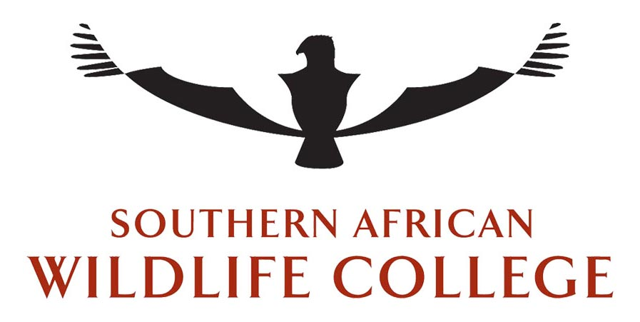

Registered as a Non-Profit Company of the Companies Act of 2008
Registration Number 1996/005726/08. 046-675-NPO. 930016093-PBO

Date:

INDEMNITY FORM

Visitors to the Southern African Wildlife College

I, the undersigned, having been given permission to enter the Southern African Wildlife College, which is situated on Kruger National Park property and which is owned by WWF-SA, and recognizing the inherent hazards that exist on premises of this nature, hereby acknowledge that I am entering the said property entirely at my own risk. I shall have no claim against the College, or any of its employees, agents or mandatories in respect of any loss, damage or injury, whether fatal or otherwise, whether such loss, injury, accident or damage is as a result of any negligent act or omission on the part of the College, or any of its employees, agents, mandatories or independent contractors or by way of the use of defective materials, or equipment supplied by the College, or by way of any human or mechanical error, default or failure occurring on the said property or whether such accident, injury, loss or damage occurs from any other cause, nothing at all.
Important Notice:
No person is allowed to handle any wildlife (including snakes and rodents) within the College Campus or the College’s training area.

Address: ________________

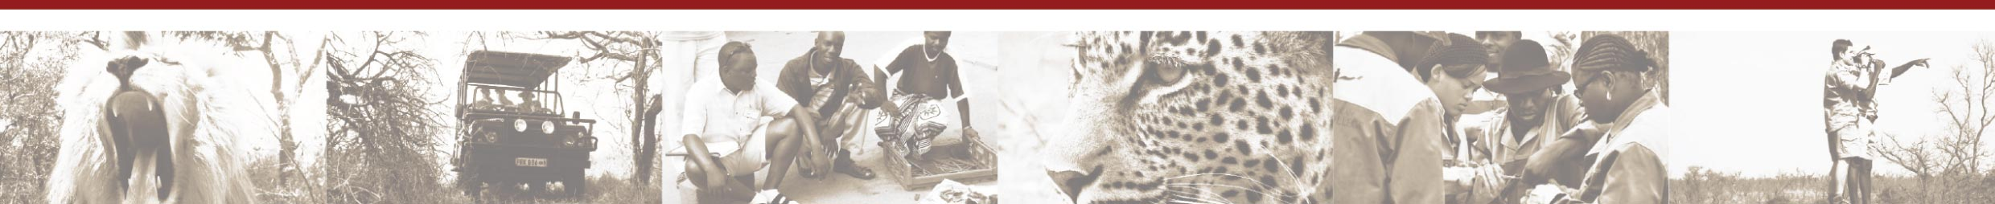
Signature: Date:

