Celebrating World Rangers Day in Mapungubwe
Transfrontier Conservation is an initiative where participating countries jointly conserve and manage the use of natural, biological and cultural resources in a sustainable manner. Greater Mapungubwe Transfrontier Conservation Area (GMTFCA) straddles the confluence of the Limpopo and Shashe rivers where Botswana, South Africa and Zimbabwe meet. On the 31st of July 2015, the South African National Parks celebrated World Rangers Day at the Mapungubwe National Park Auditorium and Confluence Viewpoint in the Limpopo province. The event commemorated Rangers killed or injured in the line of duty and the work that they do to protect the world’s natural and cultural treasures.
The following stakeholders were amongst the dignitaries who attended this event: SANParks Honorary Rangers, South African National Defense Force, SAPS, Department of Social Development, BSP, Working on Fire, Mustown Theatre, K- 9 Unit, La Familia Crew, Rangers from Botswana and Rangers from Zimbabwe

The main objective of the event was to honour the work that the men and women in National and International Parks execute in order to protect our environment, to also recognise the sacrifice that they have made by pledging their lives to ensure that future generations get to marvel at the natural heritage that our planet has to offer.

The event was also a huge eye opener to all who attended as it showed the momentous task that the Rangers play in keeping our wild life safe. It also highlighted the fact that wilderness and its wildlife is ultimately and irrevocably linked to the expertise, ethics and motivation of those tasked with the “on the ground” protection and management of these priceless assets.

The festivities were concluded with a number of activities that demonstrated the day to day functions of the Rangers i.e. how they arrest poachers and Mapungubwe Park Manager, Mr Conrad Strauss handing over a Cyber Tracker to the Botswana Ranger to ensure that they are equipped to carry out their primary responsibility of maintaining the integrity of wilderness areas, protected areas and other natural areas in which they work in.

Collection of photos of the day.

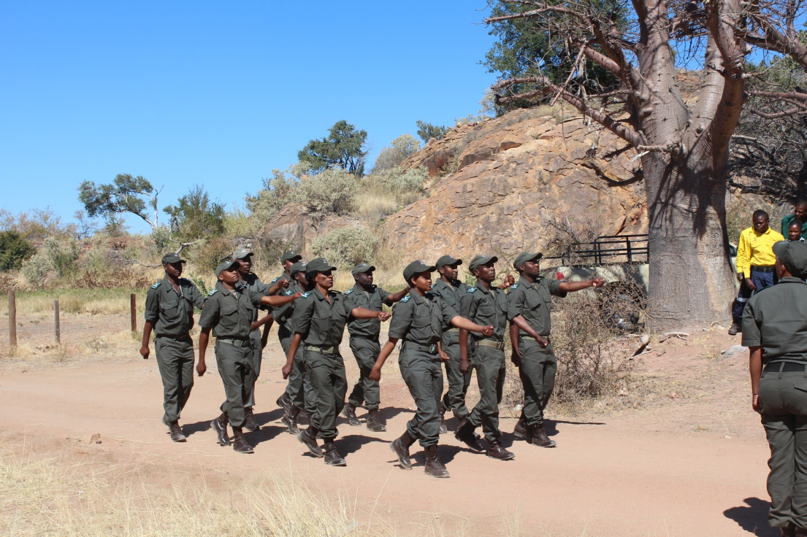
Caption: Rangers during the Drill
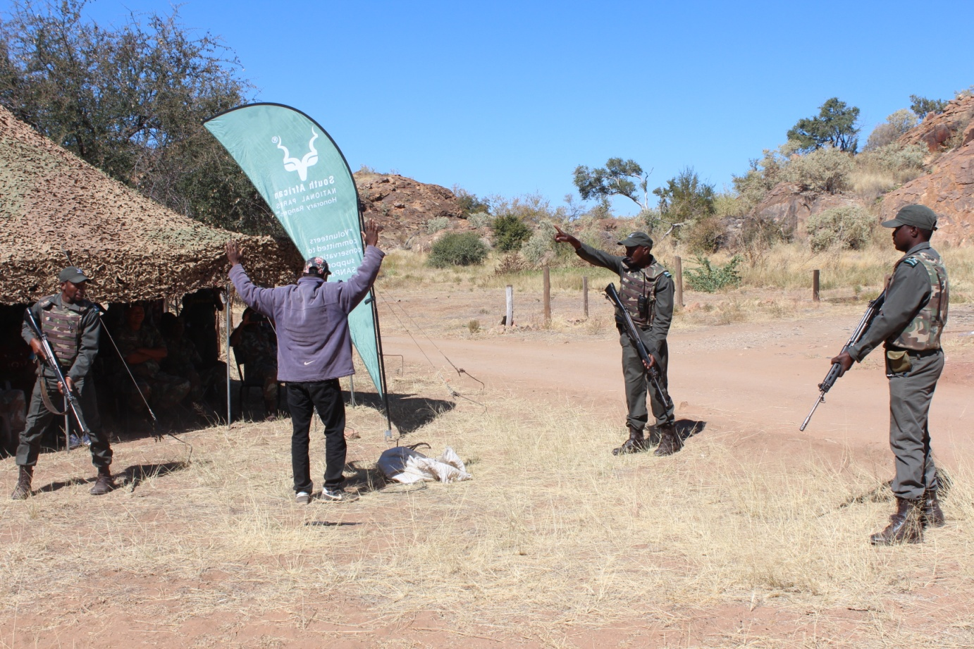Caption: Rangers demonstrating how they Arrest a Poacher
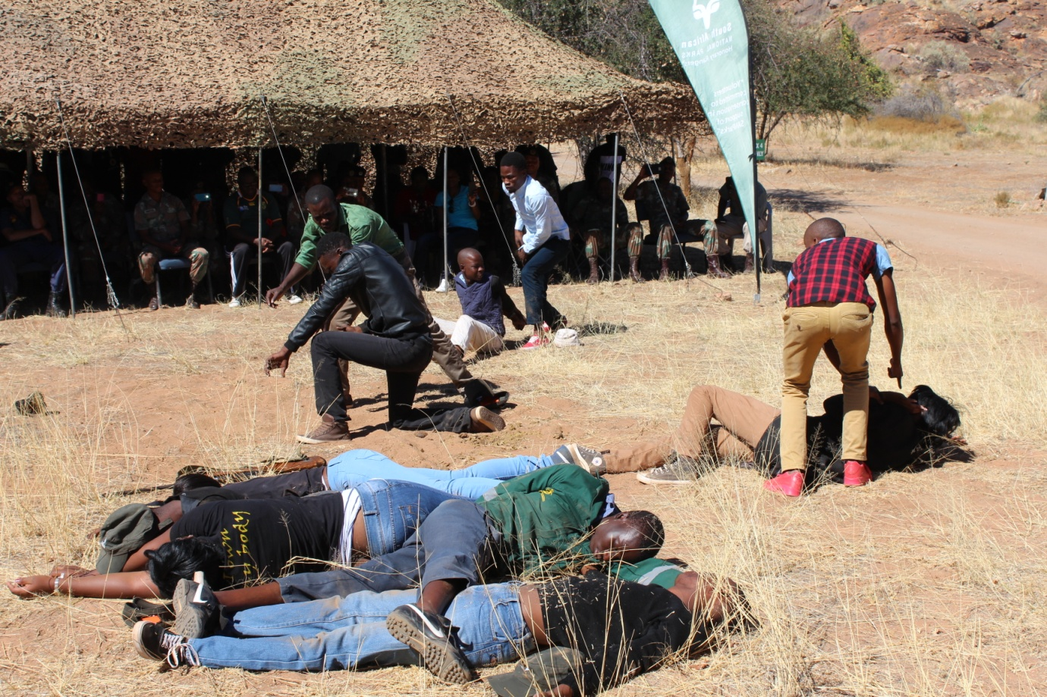 Caption: Mustown Theatre Group during their performance
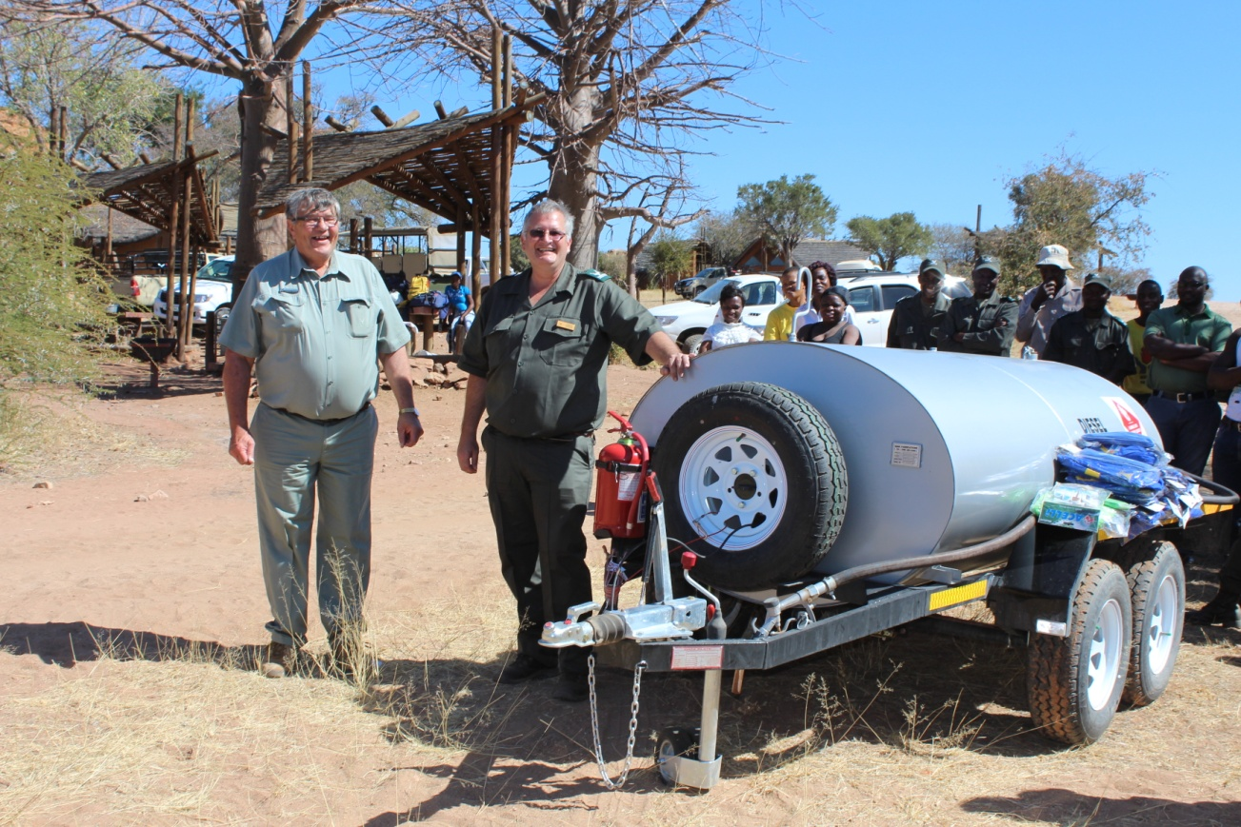 Caption: Official Handover of the diesel Bowser from the Honorary Rangers.
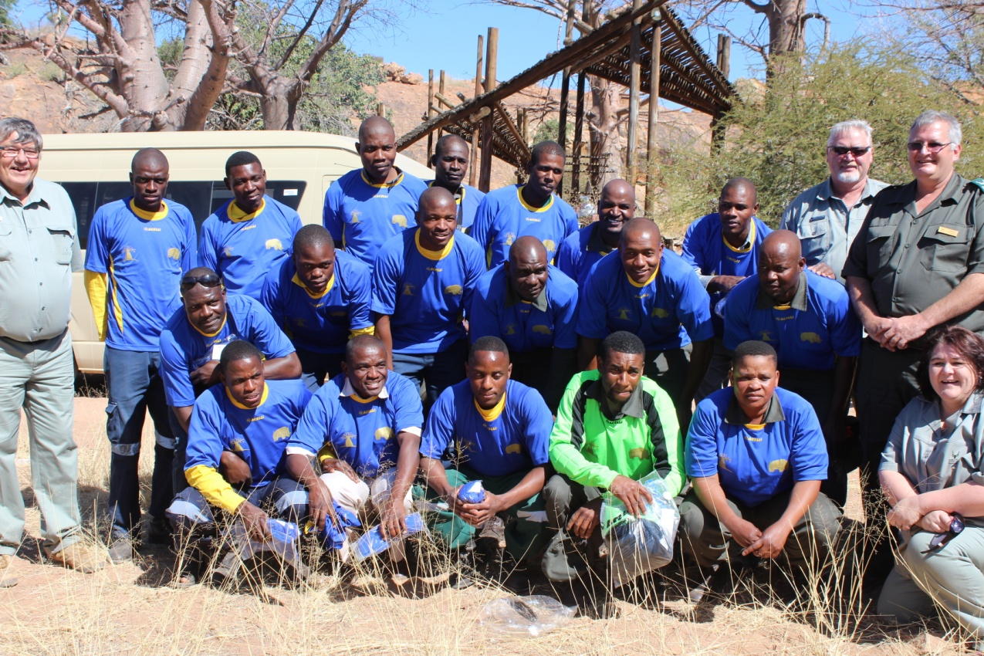 Caption: The Honorary Rangers with the Western side rangers wearing their donated Soccer gear.
Caption: Mr. Conrad Strauss handing over a Cyber Tracker to the Botswana Ranger.

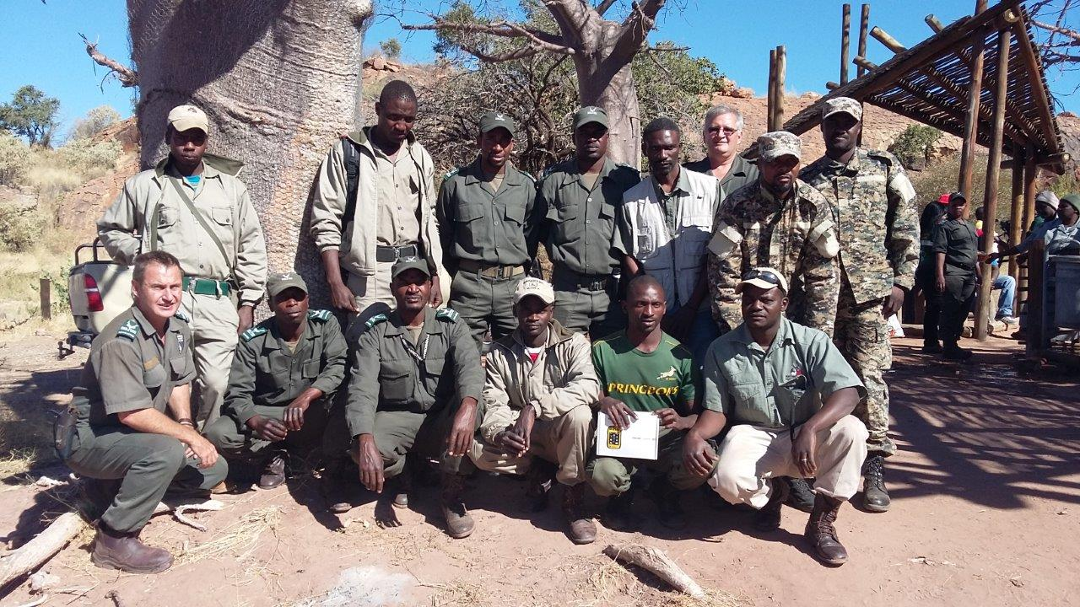Caption: Mapungubwe Rangers with Rangers from Botswana and Zimbabwe
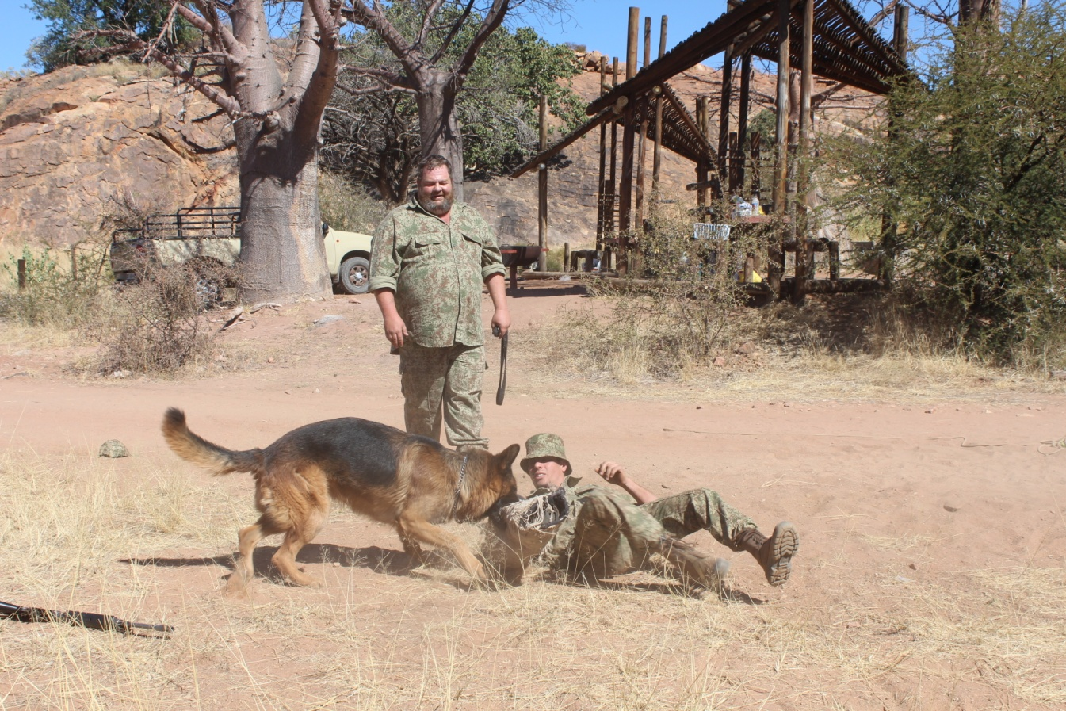 Caption: A K9 demonstration of how to arrest a poacher as well as protect evidence
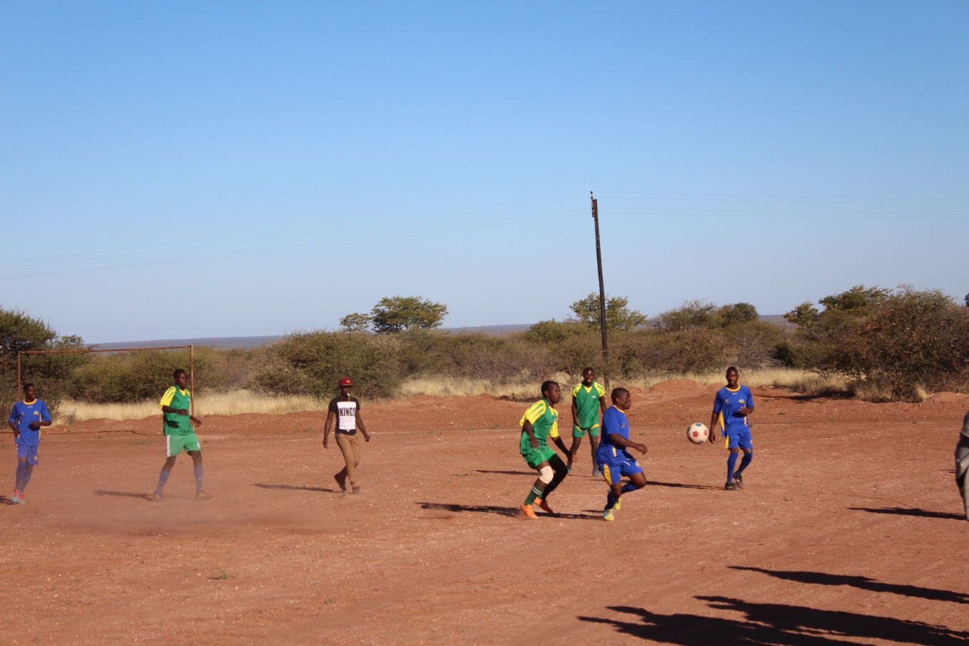 Caption: The day ended with a friendly match between the rangers and the BSP Team

